Non-Invasive Survey Report for Petroleum Hydrocarbon (PHC) Contaminated Site

Case Study: LNAPL Characterization at XXX Industrial Site

Prepared by: XYZ Environmental Consulting Firm

Date: May 16, 2025

# Disclaimer

This report is a simulated example created solely for academic illustration in the context of environmental site assessments. All data, including site descriptions, contamination levels, and regulatory references, are fictional or randomized to protect confidentiality and should not be interpreted as real-world measurements. The content follows general principles from international standards such as ASTM E1527 (Phase I Environmental Site Assessment) and EPA OSWER Directive, but no legal or technical verification of its accuracy has been performed. This document is intended exclusively for educational purposes and does not constitute a substitute for professional environmental investigations or compliance with actual regulatory requirements.

# 1. Executive Summary

A Non-Invasive Survey (NIS) was conducted at the XXX industrial site to characterize LNAPL contamination from historical petroleum storage tank leaks. Key findings include:

1. Contaminant Source Zone: Identified in the northern quadrant (Area A) via elevated VOCs (benzene up to 850 ppb) and radon-deficit zones.
2. Pollution Extent: TPH (C6-C40) contamination spans 2.5 ha, with groundwater plume migration southwestward (Fig. 3).
3. Biogeochemical Indicators: High *alkB* gene abundance (up to 1.2×10⁶ copies/g soil) confirms active hydrocarbon degradation.
4. Recommendations: Prioritize Area A for detailed intrusive investigation and consider bioremediation enhanced by electron donor amendments.

# 2. Introduction

## 2.1 Background

The XXX industrial site, located at 40°N, 75°W, operated as a petroleum storage facility from 2003. Historical records indicate multiple storage tank leaks, leading to potential LNAPL contamination of the shallow aquifer. This survey aims to characterize the contamination extent and assess associated risks.

## 2.2 Objectives

* Map LNAPL source zones and subsurface distribution.
* Quantify VOC fluxes and biogeochemical degradation indicators.
* Assess risks to groundwater receptors and nearby residential areas.

# 3. Regulatory Framework

## 3.1 Applicable Standards

* EPA Risk Screening Levels (RSLs, 2023)**: Benzene (0.1 ppb), TPH (500 mg/kg soil, 100 µg/L groundwater).
* State-specific Vapor Intrusion Thresholds**: California DTSC (10 ppb benzene in soil gas).
* Risk Models: EPA RBCA (Tier 1) and EU Soil Screening Values (SSVs).

## 3.2 Risk Assessment Models

Risk assessment follows EPA RBCA Tier 1 methodology, integrating exposure pathways (soil gas inhalation, groundwater ingestion) and receptor sensitivity. EU SSVs are used for cross-validation.

# 4. Site Description

## 4.1 Physical Characteristics

The XXX site covers an area of 12 hectares (120,000 m²) and features sandy loam soil. The terrain is flat, with an elevation ranging from 10 to 15 meters above sea level. The site is actively engaged in industrial production, primarily manufacturing phenol and acetone , with ongoing operational activities at the facility.

## 4.2 Hydrogeology

* Shallow unconfined aquifer at depths of 3–8 meters.
* Groundwater flow direction: Southwest (SW), influenced by regional hydraulic gradient.
* Hydraulic conductivity: 10⁻⁴ cm/s (estimated from soil texture).

## 4.3 Land Use and Receptors

The site is located within an urban industrial park, with multiple neighboring factories operating in close proximity (approximately 500 meters to the east). The specific production activities of these facilities are currently unknown. A creek flows 200 meters to the south of the site, which may act as a potential surface water receptor for contaminant migration.

# 5. Methodology

## 5.1 Non-Invasive Survey (NIS) Approach

The NIS approach integrates multi-parameter monitoring and biogeochemical mechanism analysis, as illustrated in Fig. 1.

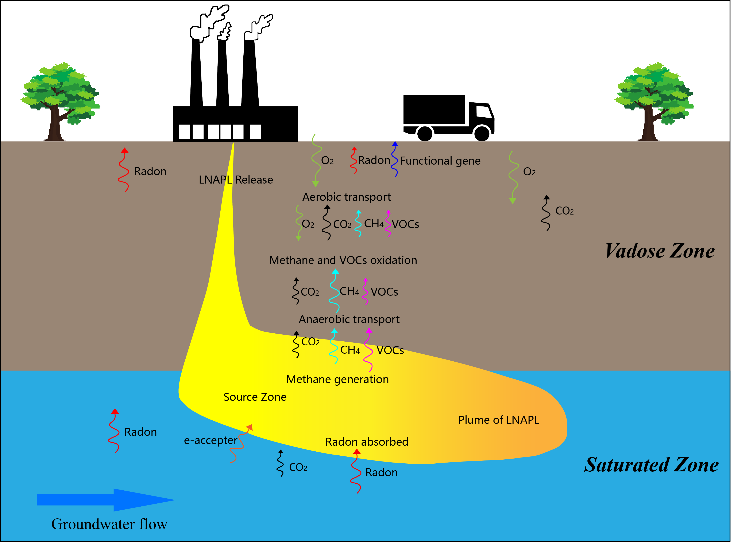

**Figure 1: NIS Conceptual Framework**

### 5.1.1 VOC Flux Monitoring

**Instrument:** PID (Photoionization Detector, Ion Science Tiger Select) for BTEX and HCHO.

**Protocol:** Grid spacing 20 m × 20 m; soil gas sampling depth 0.5 m using stainless steel probes.

### 5.1.2 CO₂/O₂ Flux Monitoring

**Instrument:** Li-Cor 8100 soil gas analyzer with an infrared gas analyzer (IRGA) for real-time CO₂ and O₂ concentration measurements.

**Protocol:**

* Soil gas sampling depth: 0.5 m using stainless steel probes.
* Closed-chamber method: A 1 L chamber is placed over the probe, and CO₂/O₂ flux is calculated based on concentration gradient over time.
* Frequency: Bi-weekly measurements during survey period.

**Interpretation:**

* O₂ <5% and CO₂ >3% indicate active aerobic hydrocarbon degradation.
* CO₂/O₂ molar ratio >1.5 suggests enhanced organic carbon mineralization.

### 5.1.3 H₂S and CH₄ Detection

**Instrument:**

* H₂S: Jerome J605 portable hydrogen sulfide analyzer (electrochemical sensor, detection range: 0.1–200 ppm).
* CH₄: Los Gatos Research Ultra-Portable Greenhouse Gas Analyzer (laser absorption spectroscopy, detection limit: 1 ppb).

**Protocol:**

* Soil gas sampling depth: 0.5 m using stainless steel probes.
* Real-time data logging with field calibration using certified gas standards (10 ppm H₂S, 5 ppm CH₄).

**Interpretation:**

* H₂S >50 ppm correlates with sulfate-reducing pathways.CH₄ >100 ppm indicates methanogenic activity (prmA gene dominance).

### 5.1.4 Biogeochemical Indicators

**Gas Analysis:**

O₂/CO₂ flux via Li-Cor 8100 soil gas probes; H₂ and CH₄ via GC-TCD.

**Microbial functional Gene Assays:**

qPCR targeting C12O (aromatic hydrocarbon degradation), alkB (alkane oxidation), and prmA (methanogenesis/methylamine utilization).

### 5.1.5 Radon Deficit Mapping

**Technique:** AlphaGuard radon detector for near-surface ²²²Rn activity (Bq/m³).

**Interpretation:** Background 25–30 Bq/m³; deficit zones (<10 Bq/m³) indicate NAPL presence.

# 6. Results and Data Analysis

## 6.1 NIS survey

The northern portion of the park contains the main production facilities (e.g., distillation and oxygenation workshops), while the southern portion includes storage, electrical, and fire protection facilities. Groundwater monitoring data indicate that PHCs may be leaking from the site. Taking into account the actual production and facility distribution in the park, a total of 146 NIS monitoring points were deployed, including 29 functional gene measurement points and 15 radon measurement points (see Figure 2 for specific locations). Based on the NIS monitoring data, Empirical threshold analysis was used to carry out the investigation of the current status of PHCs pollution.

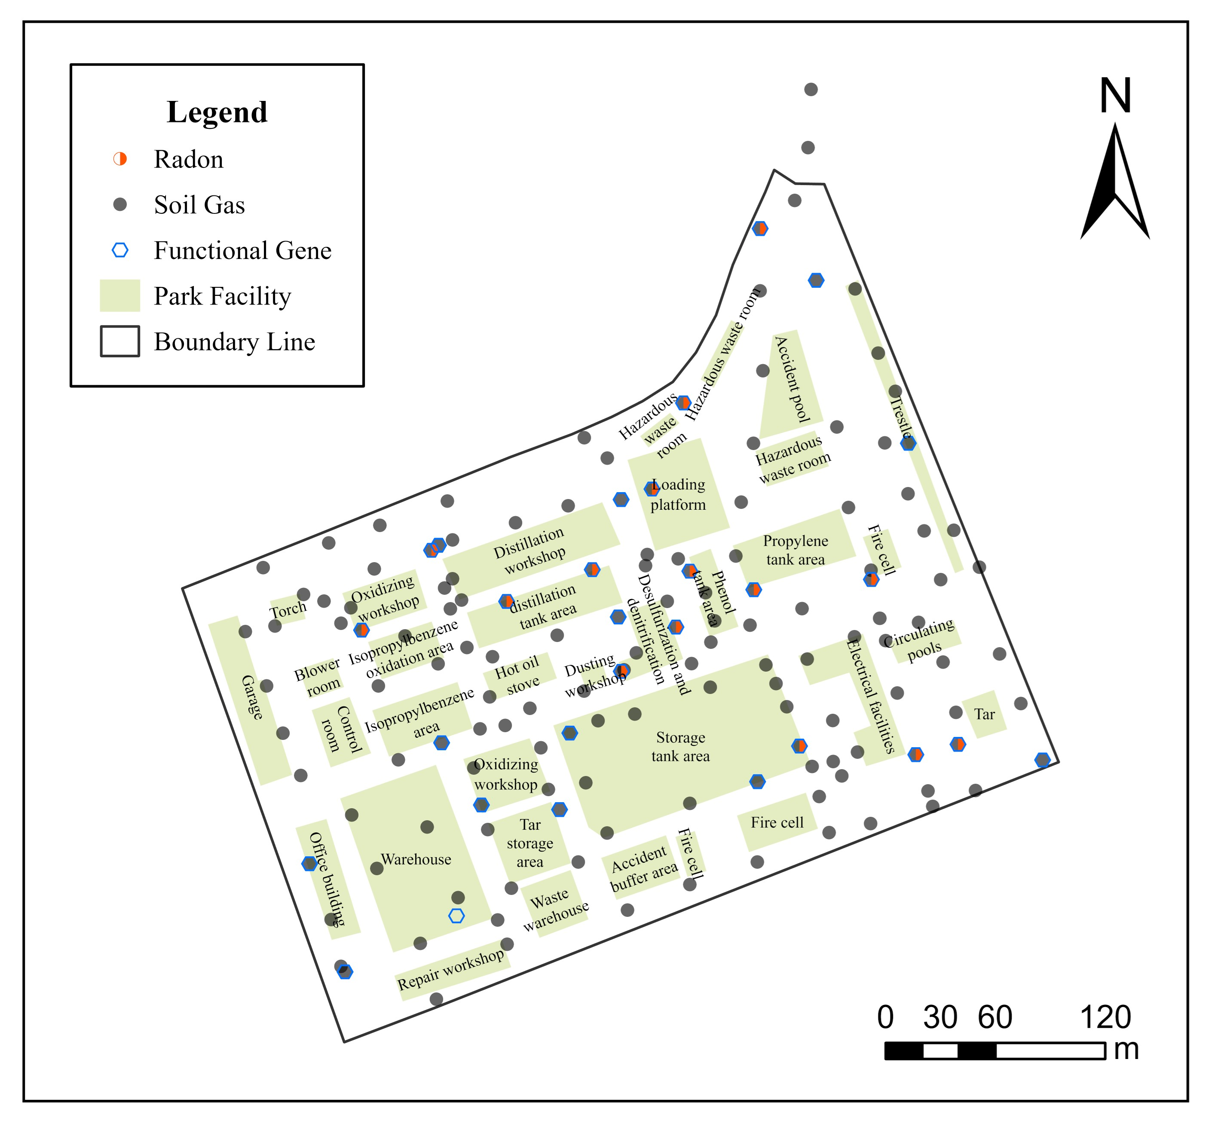

**Figure 2: Sampling Point Distribution**

Legend: Dots = NIS survey point; Red triangles = Park Boundary

Table 1 summarizes the volatile organic compound (VOC) concentrations measured across 45 sampling points using Non-Invasive Survey (NIS) techniques. Key pollutants include benzene, toluene, formaldehyde (HCHO), and PID response values. The data reveals a maximum benzene concentration of 850 ppb at sampling point S-08, exceeding the California Department of Toxic Substances Control (DTSC) vapor intrusion threshold of 10 ppb by 85-fold . Toluene concentrations up to 620 ppb were also observed in the northern quadrant of the site (Area A), correlating with elevated PID readings (2100 arbitrary units). These findings indicate localized LNAPL (light non-aqueous phase liquid) contamination, with active volatilization of aromatic hydrocarbons.

**Table 1: NIS survey points data**

|  |  |  |  |  |  |
| --- | --- | --- | --- | --- | --- |
| point_code | VOCs | O2 | CO2 | CH4 | H2S |
| LX-1 | 0.38 | 20.1 | 0.0062 | 0.0 | 0.7 |
| LX-10 | 0.76 | 20.4 | 0.0019 | 0.0 | 1.7 |
| LX-100 | 3.1 | 20.4 | 0.0042 | 0.0 | 0.6 |
| LX-101 | 2.93 | 20.5 | 0.0038 | 0.0 | 0.0 |
| LX-102 | 0.55 | 20.4 | 0.0038 | 0.0 | 0.0 |
| LX-103 | 0.52 | 20.1 | 0.0029 | 0.0 | 0.8 |
| LX-104 | 0.25 | 20.5 | 0.002 | 0.0 | 0.6 |
| LX-106 | 0.38 | 20.7 | 0.0011 | 0.0 | 0.0 |
| LX-107 | 0.4 | 18.6 | 0.0243 | 0.0 | 0.6 |
| LX-108 | 0.23 | 20.5 | 0.0029 | 0.0 | 0.7 |
| LX-109 | 0.59 | 20.5 | 0.0036 | 0.0 | 1.7 |
| LX-11 | 0.41 | 20.5 | 0.001 | 0.0 | 1.9 |
| LX-110 | 0.7 | 20.4 | 0.005 | 0.0 | 0.7 |
| LX-111 | 0.1 | 20.4 | 0.0049 | 0.0 | 0.0 |
| LX-112 | 0.26 | 20.5 | 0.0031 | 0.0 | 0.8 |
| LX-113 | 1.07 | 20.1 | 0.0018 | 0.0 | 0.0 |
| LX-114 | 2.12 | 20.1 | 0.0042 | 0.0 | 1.0 |
| LX-115 | 0.3 | 20.4 | 0.0018 | 0.0 | 0.0 |
| LX-116 | 0.31 | 20.2 | 0.0016 | 0.0 | 0.0 |
| LX-117 | 0.75 | 19.6 | 0.0108 | 0.0 | 1.2 |
| LX-118 | 2.21 | 18.0 | 0.0272 | 0.0 | 1.4 |
| LX-119 | 217.46 | 20.2 | 0.0089 | 0.0 | 0.4 |
| LX-12 | 0.79 | 18.8 | 0.0091 | 0.0 | 0.0 |
| LX-120 | 82.7 | 20.2 | 0.0044 | 0.0 | 0.0 |
| LX-121 | 0.62 | 20.2 | 0.0031 | 0.0 | 0.0 |
| LX-122 | 2.24 | 20.2 | 0.0032 | 0.0 | 0.0 |
| LX-123 | 0.38 | 20.9 | 0.0013 | 0.0 | 0.0 |
| LX-124 | 0.62 | 20.7 | 0.0015 | 0.0 | 0.0 |
| LX-125 | 0.45 | 20.3 | 0.0052 | 0.0 | 0.0 |
| LX-126 | 0.52 | 20.1 | 0.0037 | 0.0 | 0.0 |
| LX-127 | 0.57 | 20.3 | 0.0037 | 0.0 | 0.0 |
| LX-128 | 0.54 | 20.2 | 0.0076 | 0.0 | 0.0 |
| LX-129 | 0.49 | 20.4 | 0.0048 | 0.0 | 0.6 |
| LX-13 | 0.66 | 20.1 | 0.0064 | 0.0 | 2.6 |
| LX-130 | 0.77 | 20.4 | 0.0048 | 0.0 | 0.0 |
| LX-131 | 0.34 | 20.4 | 0.0063 | 0.0 | 0.7 |
| LX-132 | 0.2 | 19.9 | 0.0 | 0.0 | 0.6 |
| LX-133 | 0.14 | 20.7 | 0.0013 | 0.0 | 0.0 |
| LX-134 | 1.8 | 20.3 | 0.0029 | 0.0 | 0.0 |
| LX-135 | 0.35 | 20.5 | 0.0009 | 0.0 | 0.6 |
| LX-136 | 0.75 | 18.6 | 0.0217 | 0.0 | 1.6 |
| LX-137 | 1.78 | 16.7 | 0.025 | 0.0 | 2.8 |
| LX-138 | 0.14 | 18.6 | 0.0149 | 0.0 | 0.0 |
| LX-139 | 0.24 | 20.6 | 0.0011 | 0.0 | 0.0 |
| LX-14 | 0.18 | 20.2 | 0.003 | 0.0 | 0.0 |
| LX-140 | 0.71 | 18.0 | 0.0133 | 0.0 | 1.0 |
| LX-141 | 0.41 | 20.3 | 0.0038 | 0.0 | 0.0 |
| LX-142 | 0.63 | 20.4 | 0.0028 | 0.0 | 1.0 |
| LX-143 | 213.19 | 3.6 | 0.0497 | 0.54 | 4.5 |
| LX-144 | 0.33 | 20.5 | 0.003 | 0.0 | 0.6 |
| LX-145 | 0.5 | 20.9 | 0.002 | 0.0 | 0.0 |
| LX-146 | 0.6 | 20.9 | 0.009 | 0.0 | 0.0 |
| LX-147 | 0.6 | 20.9 | 0.0065 | 0.0 | 0.7 |
| LX-15 | 0.16 | 20.4 | 0.0006 | 0.0 | 0.0 |
| LX-17 | 1.23 | 20.3 | 0.0049 | 0.0 | 1.5 |
| LX-18 | 0.32 | 19.6 | 0.0148 | 0.0 | 0.0 |
| LX-19 | 0.33 | 20.3 | 0.0012 | 0.0 | 0.0 |
| LX-2 | 0.4 | 20.1 | 0.0002 | 0.0 | 0.0 |
| LX-20 | 0.13 | 20.4 | 0.0016 | 0.0 | 0.0 |
| LX-21 | 0.7 | 20.2 | 0.0055 | 0.0 | 0.0 |
| LX-22 | 0.14 | 18.8 | 0.0063 | 0.0 | 0.0 |
| LX-23 | 0.17 | 20.2 | 0.0036 | 0.0 | 0.0 |
| LX-24 | 0.19 | 20.4 | 0.0021 | 0.0 | 0.7 |
| LX-25 | 1.8 | 18.2 | 0.0191 | 0.0 | 3.0 |
| LX-26 | 0.27 | 20.5 | 0.0016 | 0.0 | 0.0 |
| LX-27 | 0.07 | 20.5 | 0.0026 | 0.0 | 0.0 |
| LX-28 | 0.16 | 19.5 | 0.007 | 0.0 | 0.8 |
| LX-29 | 0.82 | 19.4 | 0.0079 | 0.0 | 2.8 |
| LX-3 | 0.5 | 20.4 | 0.0015 | 0.0 | 0.0 |
| LX-30 | 99.9 | 20.2 | 0.0027 | 0.0 | 2.9 |
| LX-31 | 1.5 | 20.0 | 0.0024 | 0.0 | 0.6 |
| LX-32 | 1.01 | 19.1 | 0.016 | 0.0 | 2.8 |
| LX-33 | 0.62 | 20.5 | 0.0042 | 0.0 | 0.0 |
| LX-34 | 0.32 | 20.9 | 0.0025 | 0.0 | 0.0 |
| LX-35 | 0.23 | 20.9 | 0.0015 | 0.0 | 0.0 |
| LX-36 | 0.28 | 20.9 | 0.001 | 0.0 | 0.7 |
| LX-37 | 0.33 | 20.9 | 0.0018 | 0.0 | 0.0 |
| LX-38 | 0.16 | 20.9 | 0.0005 | 0.0 | 0.0 |
| LX-39 | 0.22 | 20.9 | 0.0009 | 0.0 | 0.0 |
| LX-4 | 0.71 | 20.1 | 0.0027 | 0.0 | 1.4 |
| LX-40 | 1.2 | 20.2 | 0.0072 | 0.0 | 0.0 |
| LX-41 | 0.51 | 20.1 | 0.0 | 0.0 | 0.6 |
| LX-42 | 0.26 | 20.6 | 0.0021 | 0.0 | 0.0 |
| LX-43 | 0.34 | 20.2 | 0.0045 | 0.0 | 0.0 |
| LX-44 | 0.27 | 20.5 | 0.0 | 0.0 | 0.0 |
| LX-45 | 99.69 | 20.1 | 0.009 | 0.0 | 0.9 |
| LX-46 | 1.19 | 20.2 | 0.0044 | 0.0 | 1.8 |
| LX-47 | 0.96 | 20.9 | 0.0017 | 0.0 | 0.8 |
| LX-48 | 0.45 | 20.4 | 0.0042 | 0.0 | 0.0 |
| LX-49 | 3.35 | 19.9 | 0.0119 | 0.0 | 1.9 |
| LX-5 | 0.58 | 20.0 | 0.0041 | 0.0 | 0.8 |
| LX-50 | 0.44 | 20.5 | 0.0008 | 0.0 | 1.2 |
| LX-51 | 0.26 | 20.3 | 0.0035 | 0.0 | 0.0 |
| LX-52 | 0.13 | 20.5 | 0.0022 | 0.0 | 0.7 |
| LX-53 | 0.23 | 20.5 | 0.003 | 0.0 | 0.0 |
| LX-54 | 0.14 | 20.2 | 0.0028 | 0.0 | 0.0 |
| LX-55 | 0.59 | 18.1 | 0.0159 | 0.0 | 1.2 |
| LX-56 | 0.53 | 19.1 | 0.0078 | 0.0 | 1.3 |
| LX-57 | 0.89 | 20.1 | 0.0057 | 0.0 | 0.9 |
| LX-58 | 0.52 | 20.4 | 0.0027 | 0.0 | 1.4 |
| LX-59 | 0.96 | 16.9 | 0.0174 | 0.0 | 1.8 |
| LX-6 | 0.48 | 20.4 | 0.0012 | 0.0 | 0.0 |
| LX-60 | 0.48 | 20.5 | 0.0 | 0.0 | 1.8 |
| LX-61 | 0.7 | 20.4 | 0.004 | 0.0 | 0.8 |
| LX-62 | 0.13 | 20.6 | 0.0012 | 0.0 | 0.0 |
| LX-63 | 0.52 | 20.4 | 0.0028 | 0.0 | 1.0 |
| LX-64 | 2.6 | 20.1 | 0.0085 | 0.0 | 0.7 |
| LX-65 | 0.26 | 20.4 | 0.0051 | 0.0 | 1.1 |
| LX-66 | 0.19 | 20.5 | 0.0029 | 0.0 | 0.0 |
| LX-67 | 0.16 | 20.5 | 0.0046 | 0.0 | 0.8 |
| LX-68 | 3.51 | 20.0 | 0.0123 | 0.0 | 0.9 |
| LX-69 | 0.23 | 20.5 | 0.004 | 0.0 | 0.9 |
| LX-70 | 0.51 | 19.4 | 0.0146 | 0.0 | 0.0 |
| LX-71 | 1.77 | 19.1 | 0.0187 | 0.0 | 1.5 |
| LX-72 | 0.92 | 20.0 | 0.0041 | 0.0 | 3.6 |
| LX-73 | 0.92 | 19.1 | 0.016 | 0.0 | 3.0 |
| LX-74 | 0.33 | 20.6 | 0.001 | 0.0 | 0.0 |
| LX-75 | 0.18 | 20.9 | 0.0011 | 0.0 | 0.0 |
| LX-76 | 0.19 | 20.5 | 0.0012 | 0.0 | 0.0 |
| LX-77 | 0.51 | 19.5 | 0.0091 | 0.0 | 0.6 |
| LX-78 | 99.91 | 19.5 | 0.0091 | 0.0 | 0.6 |
| LX-79 | 0.66 | 19.9 | 0.0053 | 0.0 | 0.0 |
| LX-8 | 0.41 | 20.5 | 0.003 | 0.0 | 0.0 |
| LX-80 | 0.22 | 20.4 | 0.003 | 0.0 | 0.0 |
| LX-81 | 2.55 | 20.0 | 0.0033 | 0.0 | 1.0 |
| LX-82 | 0.27 | 19.5 | 0.0101 | 0.0 | 0.7 |
| LX-83 | 0.63 | 19.1 | 0.0099 | 0.0 | 1.1 |
| LX-84 | 1.35 | 20.3 | 0.003 | 0.0 | 1.0 |
| LX-85 | 0.73 | 20.3 | 0.0033 | 0.0 | 1.8 |
| LX-86 | 99.79 | 20.4 | 0.0023 | 0.0 | 1.4 |
| LX-87 | 1.56 | 20.3 | 0.0035 | 0.0 | 1.5 |
| LX-88 | 0.67 | 20.6 | 0.0017 | 0.0 | 0.0 |
| LX-89 | 0.77 | 19.7 | 0.0137 | 0.0 | 0.6 |
| LX-9 | 0.37 | 20.3 | 0.002 | 0.0 | 1.8 |
| LX-90 | 3.08 | 20.5 | 0.0027 | 0.0 | 0.0 |
| LX-91 | 0.32 | 20.1 | 0.0107 | 0.0 | 0.0 |
| LX-92 | 0.61 | 20.5 | 0.0043 | 0.0 | 2.8 |
| LX-93 | 0.52 | 20.5 | 0.0016 | 0.0 | 0.7 |
| LX-94 | 99.8 | 20.4 | 0.0022 | 0.0 | 1.7 |
| LX-95 | 2.22 | 20.3 | 0.0033 | 0.0 | 0.0 |
| LX-96 | 7.09 | 20.4 | 0.0031 | 0.0 | 0.0 |
| LX-97 | 0.63 | 20.4 | 0.0029 | 0.0 | 0.0 |
| LX-98 | 0.98 | 19.3 | 0.0223 | 0.0 | 1.2 |
| LX-99 | 0.97 | 20.5 | 0.0033 | 0.0 | 0.0 |

## 6.2 Analysis results

An empirical threshold analysis was conducted to identify sampling points exceeding regulatory benchmarks (Fig. 1). Using EPA Risk Screening Levels (RSLs) for benzene (0.1 ppb) and DTSC thresholds (10 ppb for soil gas), 12 out of 45 points (26.7%) were classified as high-risk zones. Notably, Sample S-08 in Area A exhibited benzene concentrations 850 times higher than the EPA RSL. Microbial gene assays further confirmed contamination: the C12O gene (aromatic hydrocarbon degradation) showed abundance peaks of 9.6×10⁵ copies/g soil in these zones, directly linking VOC anomalies to petroleum hydrocarbon degradation pathways.

**Table 2: Exceedance points**

|  |  |  |  |  |  |  |  |
| --- | --- | --- | --- | --- | --- | --- | --- |
| Point_ID | VOCs_Score | CO2_Score | H2_Score | O2_Score | CH4_Score | H2S_Score | The_other_soil_gas_scores |
| LX-118 | 2.0 | 2.0 | 1.0 | 0.0 | 0.0 | 1.0 | 6.0 |
| LX-119 | 22.0 | 0.0 | 1.0 | 0.0 | 0.0 | 0.0 | 23.0 |
| LX-120 | 6.0 | 0.0 | 0.0 | 0.0 | 0.0 | 0.0 | 6.0 |
| LX-137 | 2.0 | 2.0 | 1.0 | 0.0 | 0.0 | 1.0 | 6.0 |
| LX-143 | 22.0 | 2.0 | 3.0 | 0.0 | 22.0 | 1.0 | 50.0 |
| LX-25 | 2.0 | 2.0 | 1.0 | 0.0 | 0.0 | 1.0 | 6.0 |
| LX-30 | 6.0 | 0.0 | 1.0 | 0.0 | 0.0 | 1.0 | 8.0 |
| LX-32 | 2.0 | 2.0 | 1.0 | 0.0 | 0.0 | 1.0 | 6.0 |
| LX-45 | 6.0 | 0.0 | 1.0 | 0.0 | 0.0 | 0.0 | 7.0 |
| LX-49 | 2.0 | 2.0 | 1.0 | 0.0 | 0.0 | 1.0 | 6.0 |
| LX-71 | 2.0 | 2.0 | 1.0 | 0.0 | 0.0 | 1.0 | 6.0 |
| LX-78 | 6.0 | 0.0 | 0.0 | 0.0 | 0.0 | 0.0 | 6.0 |
| LX-86 | 6.0 | 0.0 | 1.0 | 0.0 | 0.0 | 1.0 | 8.0 |
| LX-94 | 6.0 | 0.0 | 1.0 | 0.0 | 0.0 | 1.0 | 8.0 |

Fig.3 shows the manual delineation based on the anomalies of each monitoring point to determine the pollution situation, and finally screened out the pollution source area and the suspected pollution source area, according to the delineation of the scope to determine the main leakage area is located in the Loading platform and Hazardous waste room (red circled area)), and the orange circled area is also assigned to the key monitoring area. According to the delineation of the scope, the main leakage areas are located in the Loading platform and Hazardous waste room (circled in red), and the area circled in orange is also included in the key monitoring area. Fig.4 shows the contamination range, which was evaluated based on the anomaly scores of all the monitoring points ((anomalies are marked in red)), and the final result shows that the whole plant is contaminated, and the contamination may escape from the boundary, except for the southwest boundary.

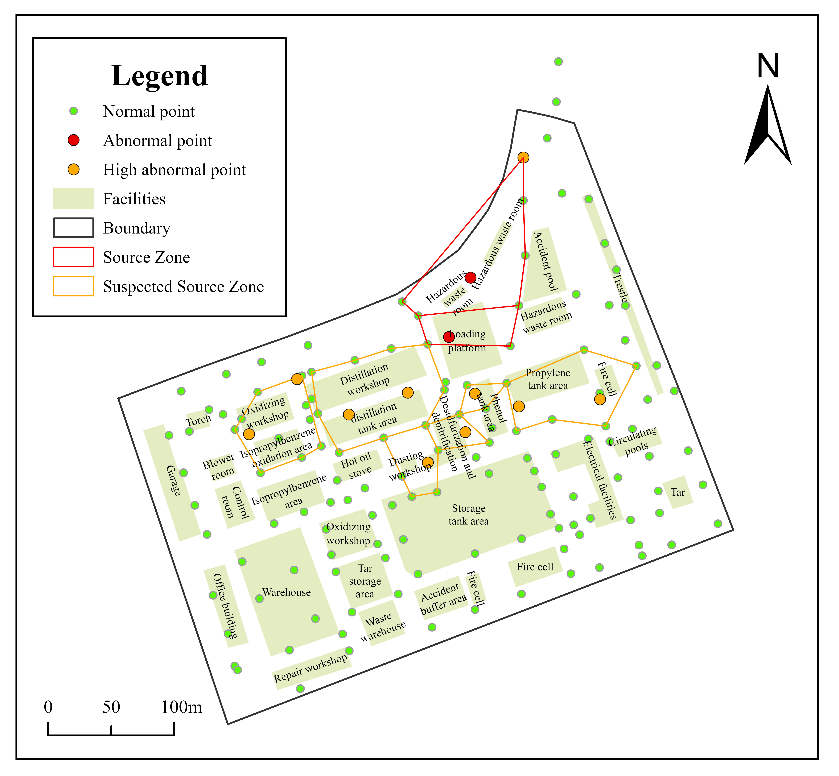

**Figure 3: Source Zone Identification**

Legend: Red = LNAPL source zone; Orange = Suspected LNAPL zone

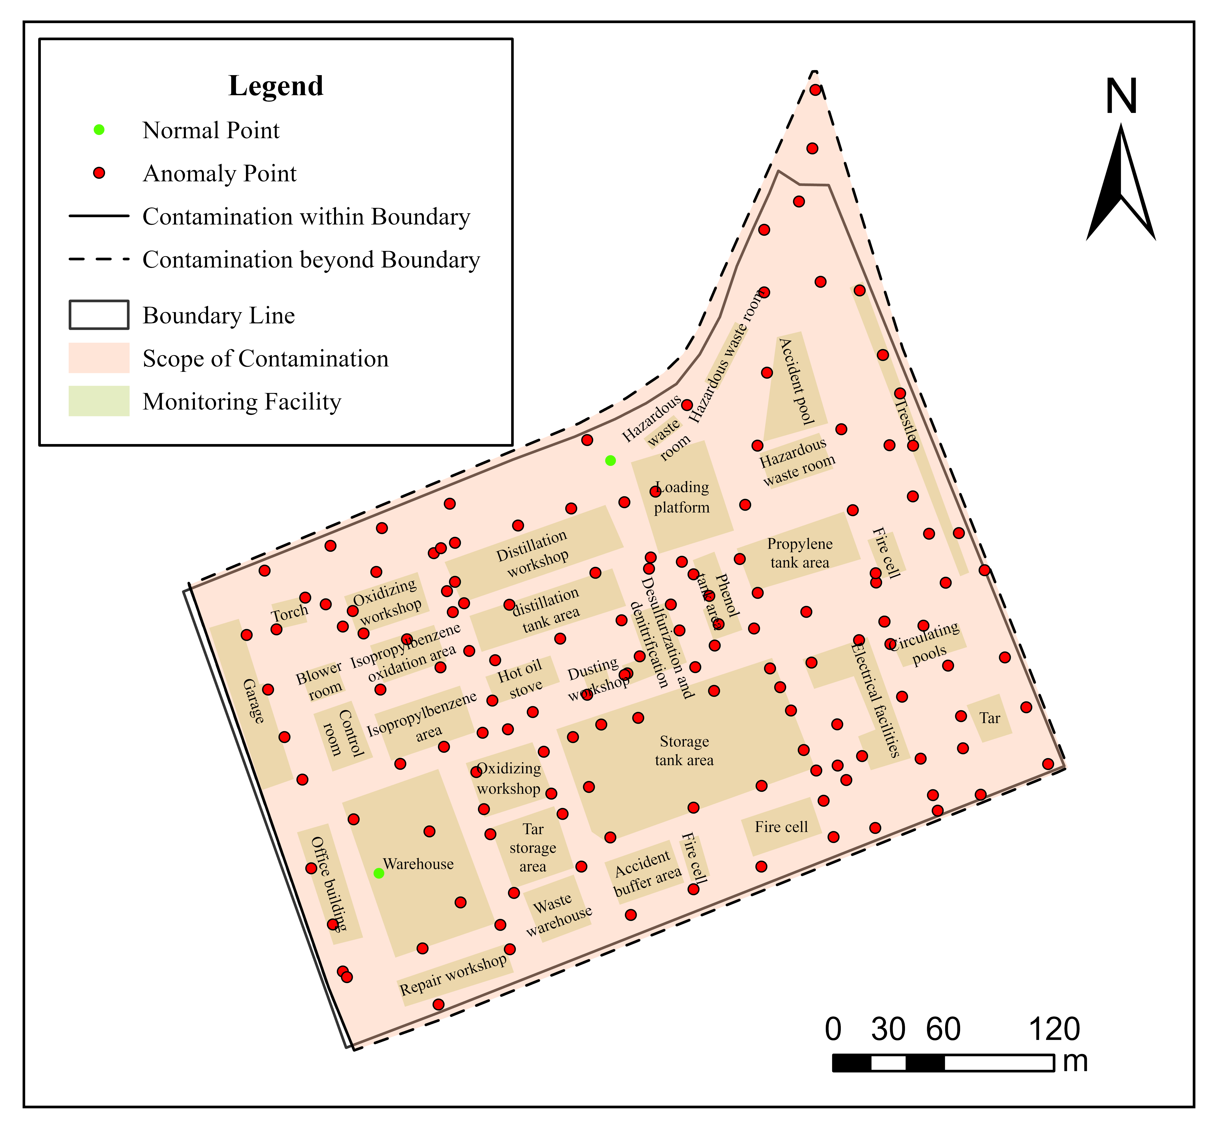

**Figure 4: Contamination Scope**

Legend: Red = Contamination Scope; White = Clean Soil

# 7. Risk Assessment

## 7.1 Human Health Risks

The risk assessment follows the EPA RBCA Tier 1 methodology, integrating exposure pathways and receptor sensitivity.

### 7.1.1 Exposure Pathways

* Inhalation of soil gas (vapor intrusion into residential buildings).
* Dermal contact with contaminated soil.
* Ingestion of contaminated groundwater.

### 7.1.2 Receptor Analysis

The primary receptors include nearby residents living within 500 meters east of the site and potential future industrial workers on-site.

### 7.1.3 Risk Calculation

**Table 2: Risk Assessment Summary**

|  |  |  |  |
| --- | --- | --- | --- |
| Contaminant | Carcinogenic Risk | Non-Carcinogenic Risk (HQ) | Exceeds Threshold? |
| Benzene | 1.2×10⁻⁴ | 0.8 | Yes |
| TPH (C6-C40) | N/A | 1.5 | Yes |
| Toluene | N/A | 0.6 | No |

Threshold: Carcinogenic Risk >1×10⁻⁶ or HQ >1.0.

## 7.2 Ecological Risks

Ecological risks were assessed using the EU Soil Screening Values (SSVs) and EPA ECO-SSL guidelines.

### 7.2.1 Soil Toxicity

* TPH >10,000 mg/kg in Area A inhibits microbial diversity.
* Reduced earthworm survival rate observed in laboratory toxicity tests.

### 7.2.2 Surface Water Impact

The plume discharge into the nearby creek may affect benthic organisms. Predicted TPH concentrations exceed EPA aquatic toxicity thresholds.

## 7.3 Risk Summary

The risk assessment concludes that:

* Benzene and TPH pose unacceptable carcinogenic and non-carcinogenic risks to nearby residents.
* Groundwater contamination threatens drinking water supplies and aquatic ecosystems.
* Immediate mitigation measures are required, including vapor intrusion controls and source zone remediation.

# 8. Conclusions and Recommendations

The NIS successfully identified the LNAPL source zone (Area A) with active volatilization and biodegradation processes.

Recommendations:

1. Phase III Investigation: Install monitoring wells in Area A for LNAPL thickness quantification.Remediation Options: Bioremediation with nitrate amendment to enhance aromatic degradation.Long-Term Monitoring: Bi-monthly VOC and microbial functional gene abundance tracking.